

“Hospital

Database

System”

**Subject:** CS306 DATABASEMANAGEMENT  
**Mentor**: prof.Emine Yaman  
**Date:** 28-05-2021

**Project members:** Mohamad Abdelrahman, Ahmed Duranović

Table of Contents

**Abstract**

- Hospital database system will be to ensure and secure easy and speed access for hospital as a seller and patient as a buyer of goods. Accessible by all registered workers, and patients.

**Glossary**

- no specific words yet.

Introduction

**Summary**

- Overall goal is to make life easier for the patients and doctors. Database system is user friendly.

-In this system everything is done from start untill the end in the best possible time.

System Features

**2.1 System Features**

SF1: Registration :Patient input ID, age, and Assurance num. And that is everything what it need to make appointment with doctor.

.

SF2: Medical record: One of the staffs of the hospital has to fill in med.record with just inputing: unique number,date,diagnosis and drugs.

SF3: Administration way- Nurs take the Med.record bring it to the Administration where the Administration will fill in the receipt.

SF4: Health Office –Patient just simply go to the Healt office and take the receipt.

|  |  |
| --- | --- |
| **Primary Users** | **Use Cases** |
| Doctor | 1. Set up Appointment  2. Fill in Med.Record  3.Establish diagnosis |
| Nurse | 1. Set up Appointment  2. Fill in Med.Record  3. Bring the Med.Record to the Administration |
| Patient | 1. Registration  2. Set up appointment  4. Take receipt |

**2.2 – ER/EERdiagram**

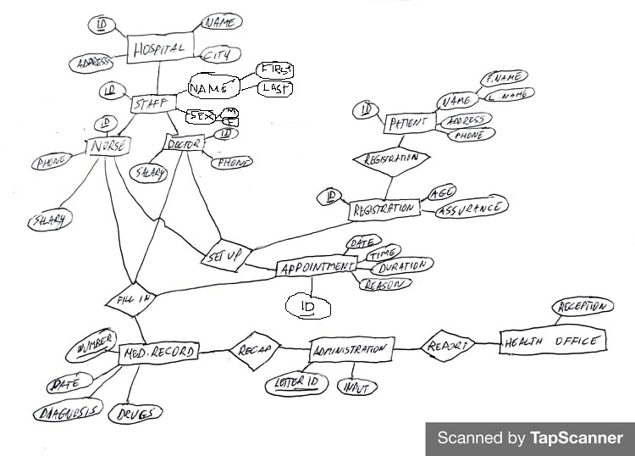

**2.3 – Relational scheme**

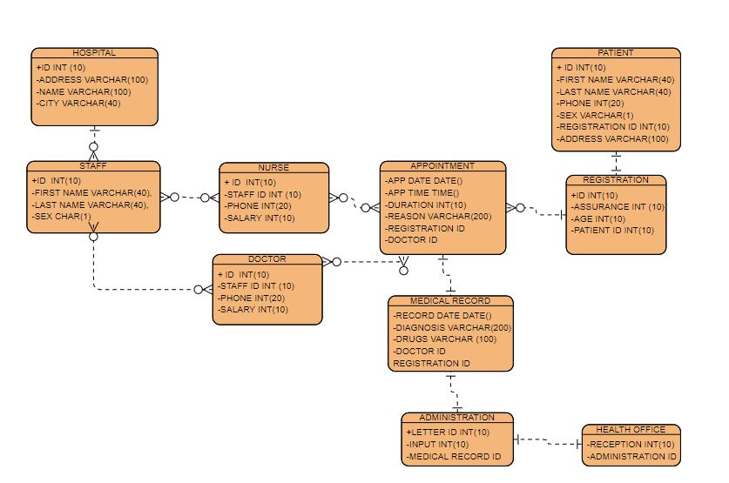

**2.4 - Evolution**

- The project is primarily based on the fact that the coronavirus pandemic has taken a toll on many peoples’ view on health both physically and mentally. This project aims to strive in the direction of never dealing with such a pandemic again or at the very least being more aware of how we treat our Health care system.

**Contribution Table**

|  |  |
| --- | --- |
| ***Member*** | ***Contribution*** |
| Mohamad Abdelrahman - team lead | finished part 4 and control and correct mistakes from part 1,2,3 |
| Ahmed Duranovic | Finished part 1,2,3 and control and correct part 4 |